THE UNITED REPUBLIC OF TANZANIA

PRESIDENT’S OFFICE - REGIONAL ADMINISTRATION AND LOCAL GOVERNMENT
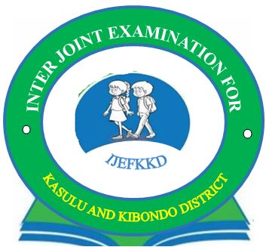

INTER JOINT FORM TWO PRIVATE EXAMINATION FOR KASULU AND KIBONDO DISTRICTS.

041
BASIC MATHEMATICS
(For Both School and Private Candidates)
Time: 2:30 Hours Tuesday, 25th June, 2019 A.m
INSTRUCTIONS:
- This paper consists of two(2) section A and B.
- Answer all questions in both sections
- Show all your work clearly.
- Mathematical table and geometrical instruments may be used.

SECTION A: (60 MARKS)
  - Change the order of digits in 47988 to make
- The largest possible number

- The smallest possible number.

  - a. Solve the equation
$\sqrt{ v+2 }$= $\frac{1}{2}$
V –2

b. Make L subject of the formula and express each in its simplest form
M = PL
L + rCR

3. a. Evaluate 365 x 365 – 135 x 135

b. The operation m*n is defined by m*n =$\frac{1}{2 }$m –n find
(i) 6* 5

(ii) (⁻2 *1) * (⁻3)

4. a. Write 5.84 x 6 in the form of A x 10^{n},1 $≤$A < 10 and A is integer correct to 2 significant figures.

b. Calculate the area of shaded part of the figure ( use $=π$ = ²²/7 )
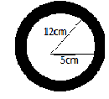

5. a. The age of a father now is three times that of his son. If five years to come the age of father will be 5
years more than twice that of his son, find their present age.

b. Eight lorry are each loaded with 12 tonnes of crude oil. Find the total mass of crude oil in kg.

6. a. Simplify the following (27)^{1/3,} (32) ^{1/5}

b. Find the value of 2xy if X² + y² = 34 and x +y = 8

7. a. Name the types of triangles shown is the figure below

- ……………………….

- …………………………

- ………………………….

b. Subtract the sum of 2⁴/5 and 4¹/2 from 8¹/10

8. a. Find the principal that will earn 9000 Shs. In 5 years at 4¹/2% per annum.

b. Without using mathematical table find the value of
(i) Sin (70 – 10)⁰

(ii) Cos (70 – 10)⁰

(iii)Tan (70 – 10)⁰

SECTION B: (40 MARKS)
9. a. Use mathematical table to find the volume of a sphere given by the formula: v=$\frac{4πr3}{3}$ If: r = 20.6cm
(take $π$= 3.142)

b. The following table shows marks of form two students in a mathematics test at Algebra Islamic Seminary.
Marks (%) | 40 | 45 | 50 | 55 | 60 | 65 | 70
Number of students | 6 | 8 | 13 | 5 | 9 | 4 | 3
- If 50% was the pass mark, how many students passed the test?

- What mark was scored by the majority of students?

- Draw the frequency polygon.

10. a. In a class of 50 students 16 students takes History, 40 students takes Physics, 7 students takes both
subjects.
- Draw a Venn diagram to represent the information

- How many students take physics only?

- How many students take neither of the subjects?

b. Find the solution of the following pair of equation graphically.
2x + y = 10
2x – 2y = 1

